DAGV 2210
Github Link: https://github.com/KiribosBriskit/DAGV-Projects
References:
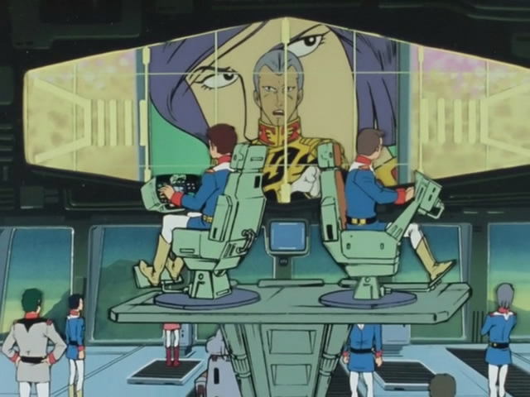
(Gundam UC 0079’s White Base)
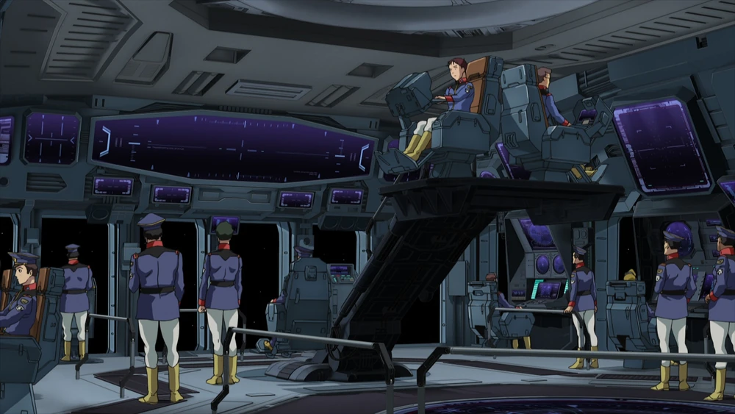
(Gundam The Origin White Base)
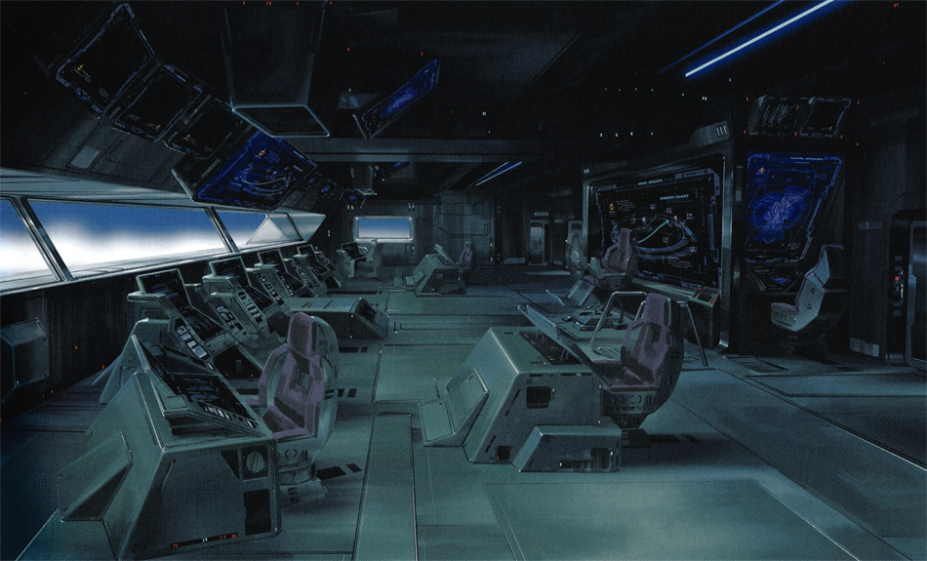
(Gundam UniCorn Clop-Class)
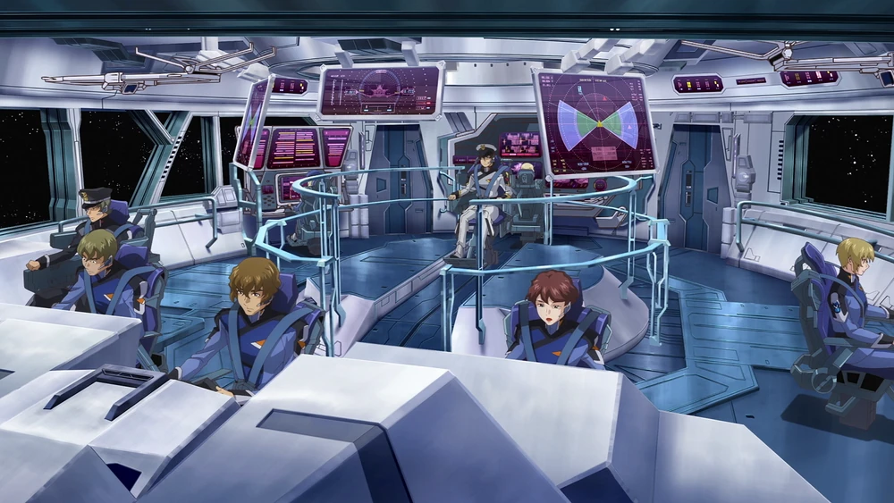
(Gundam SEED Freedom Millennium)
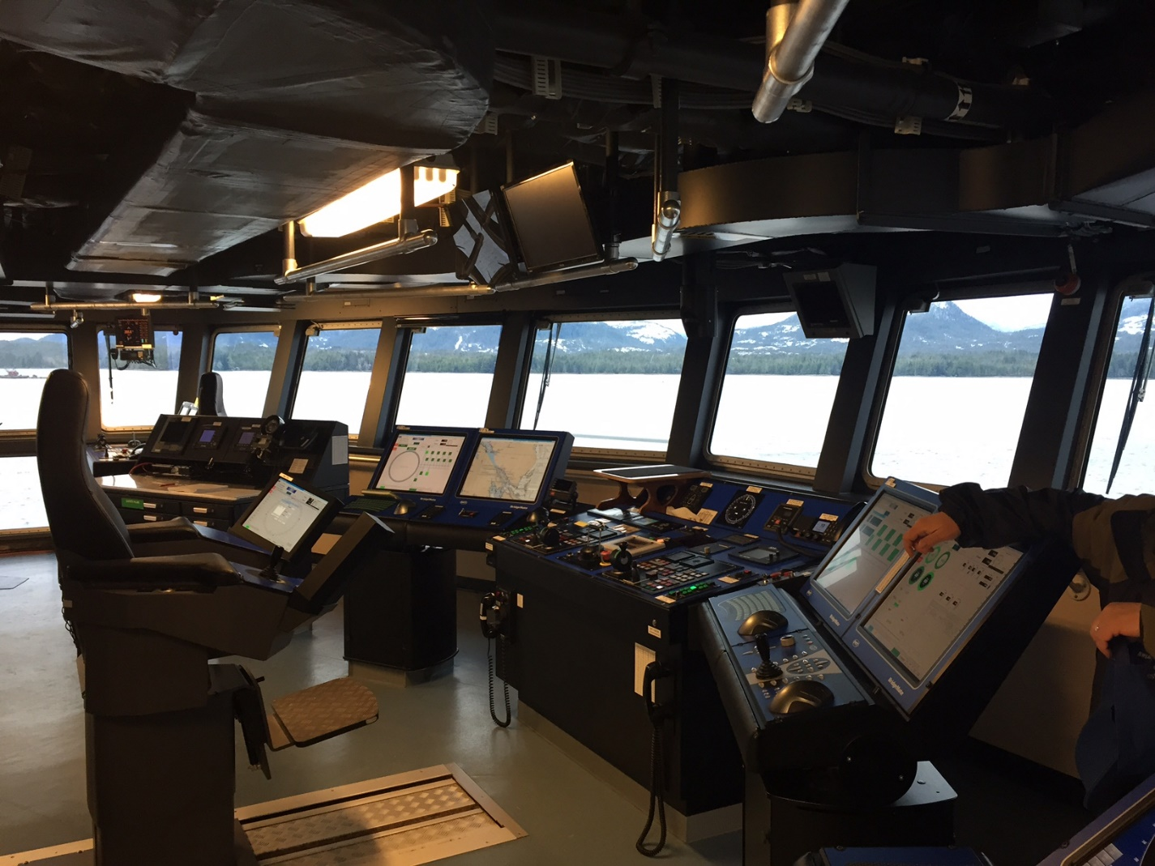
(RV Sikuliaq)
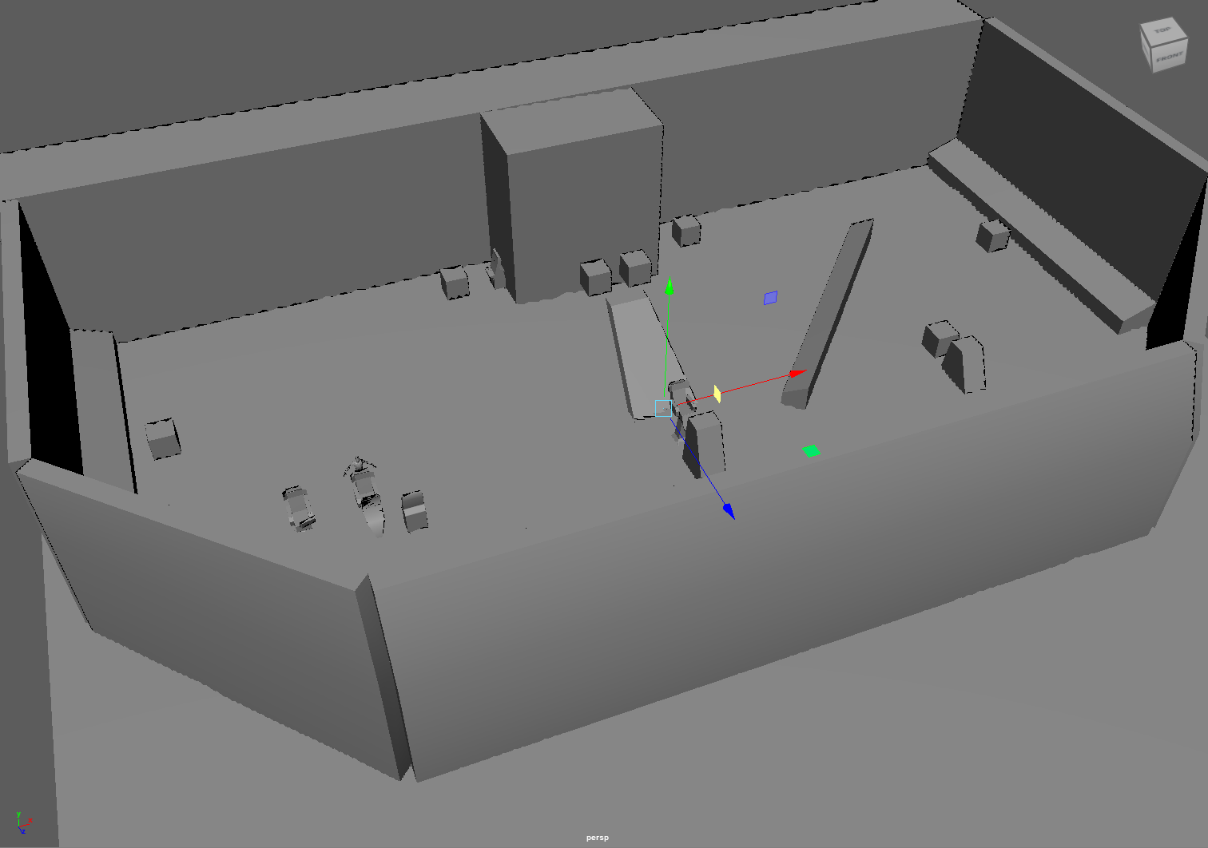
Ignore the Diagonal block on the right, still messing with the block out as I’m modeling chairs
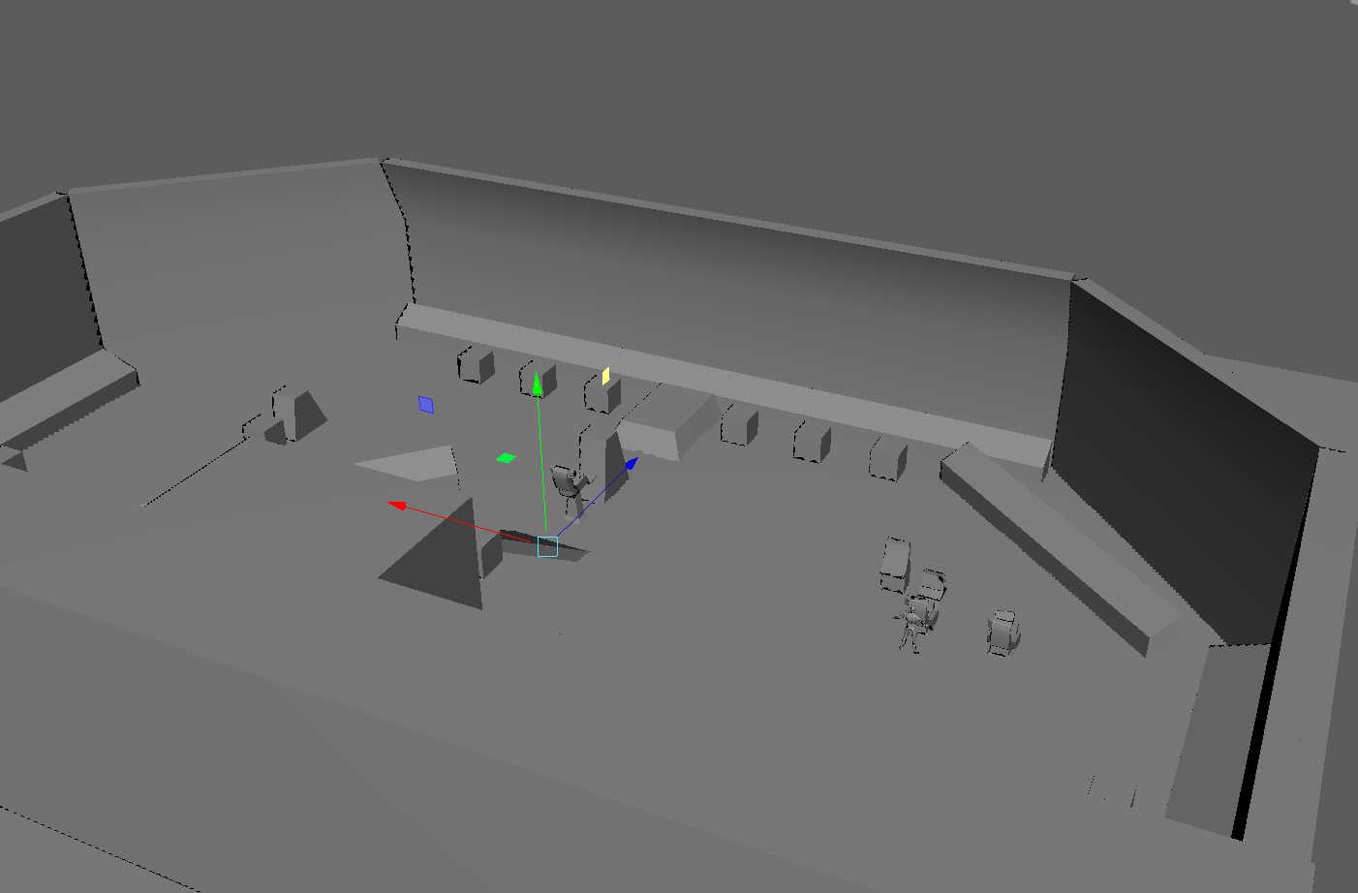
Some of the control panels still need to be messed around with
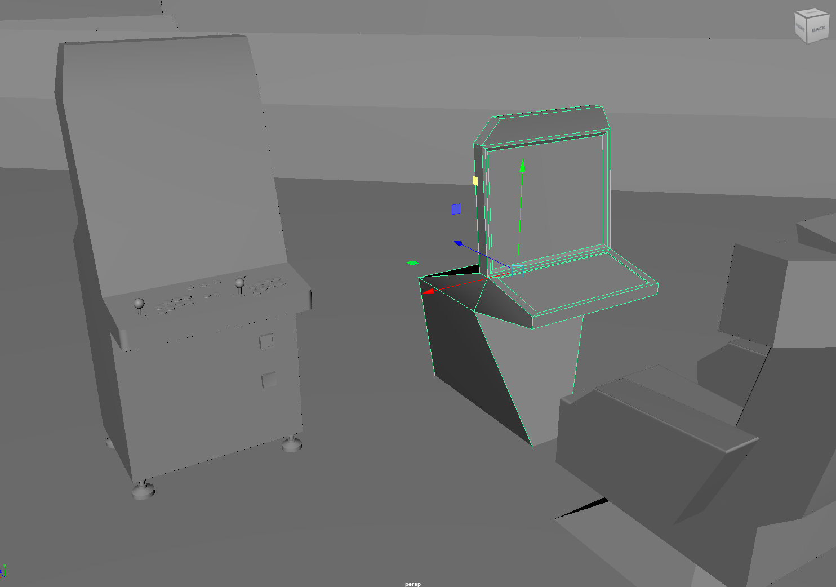
Arcade cabs are placeholders. I also used it as a reference for one of the consols cuz I thought it looked nice
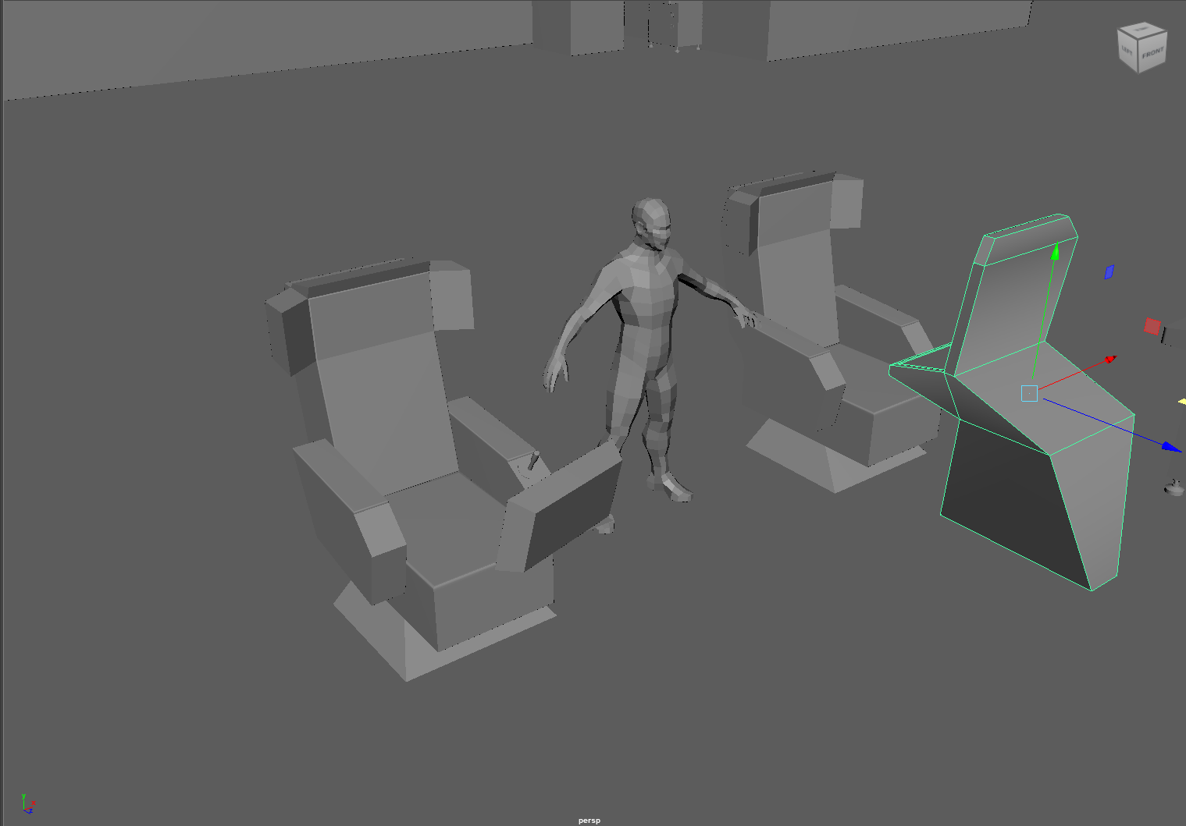
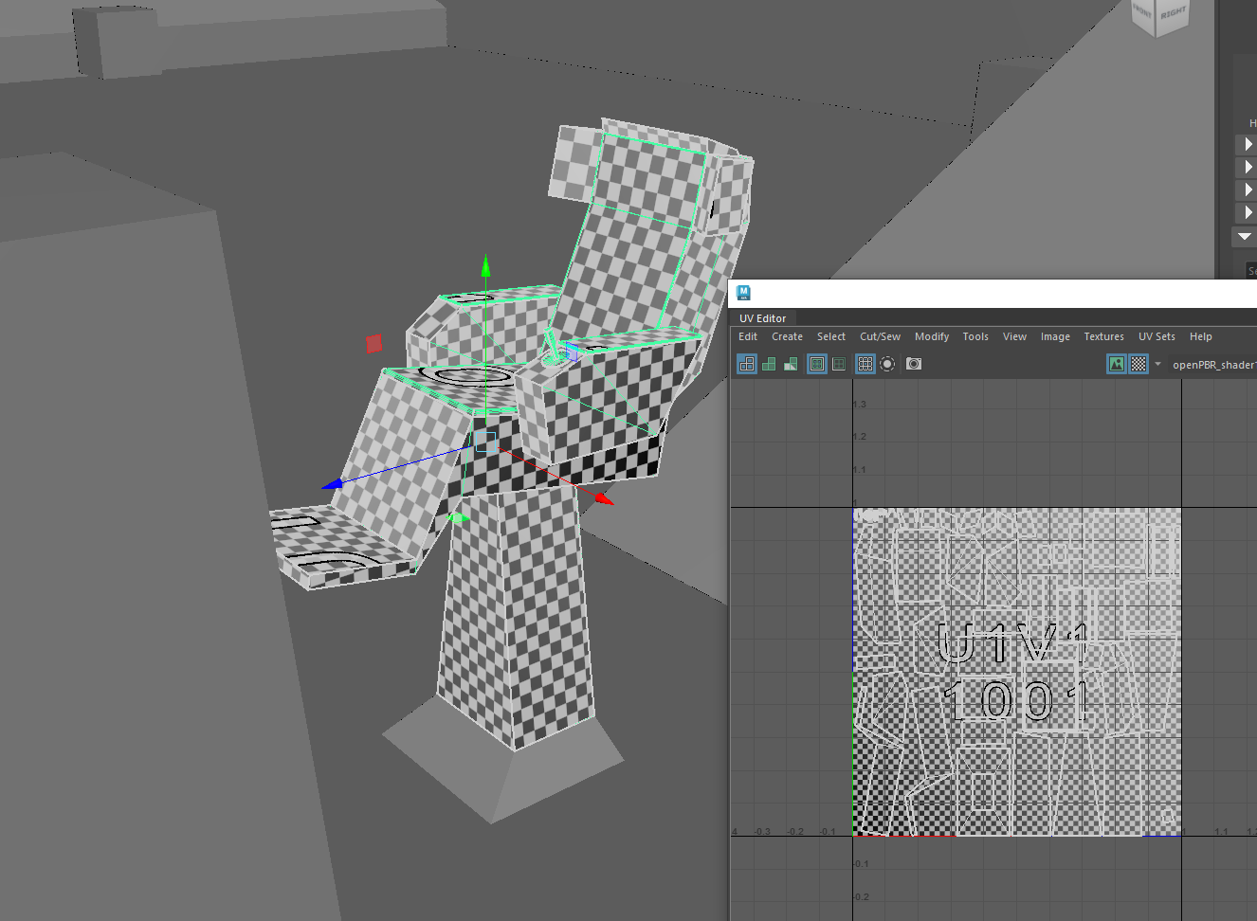
One of the reasons why I chose to model a spaceship’s bridge was because I really like Gundam. I did notice that a lot of spaceships designed in Gundam took inspiration from nautical ships. I did attempt to find more real life nautical ship bridges, but not a lot of them had a “vibe” that I was looking for, but they did make for a nice vague reference for what bridges generally looked like. Something I struggled with… strangely, was just getting myself to start working on the project in the first place.

DAGV 2240
I like comic art, especially Daniel Warren Johnson’s, so I’ve been using India Ink for most, if not all, of everything that’s black in my character design submissions. Theoretically I could’ve just done this digitally, but there are some advantages of being able to sketch and doing line art on a sketch book that never leaves me. The idea for the Shinigami/Reaper is to make them invert the archetype to some extent. Fantasy Media tends towards conservation, protecting the status quo. Their design implements “tough” aspects, such as wide shoulders and a small head in proportion with the rest of their body, like most mecha. Most of their armor is geometric and hard, as well. Their head is meant to invoke the imagery of mass produced mobile suits, specifically GMs and Jegans, as this character is essentially a tool, though skull motifs are added to look more intimidating… and kinda cool tbh. Their proportions overall is meant to feel skeletal and fragile, the spine is inspired by the Devil Gundam. Their 2 weapons are a war scythe (over a traditional scythe that Grim Reapers are typically depicted with) and an arm cannon. Their head is engulfed in flames akin to Ghost Rider. I want some spiritual elements to contrast the rest of their more human made elements, though it’s possible the skeletal body itself is just a spirit.
“The origins of the Shinigami is lost to time. Some believe they were an ancient human who lived in fear of spirits, and constructed a suit of armor to command an army of reapers. Others believe they are a law of nature, akin to entropy itself, a spirit geared against eliminating other spirits. Regardless of which form of reasoning they truly follow, their goal remains the same: Kill All Spirits. Now, one of their own reapers opposes them: Mikoto, with some dissenters sympathizing with Mikoto. The Reaper has decided to send multiple reapers after Mikoto, beginning a civil war between reapers. In the end, they’ve decided to come out of hiding for the first time in centuries to deal with Mikoto themselves.”
Notes/Excuses: Didn’t have time to scan and color my submission this time. Had a difficult time getting into 3D modeling assignment and lagged behind on others stuff as a result. Also, I have an hour/hour and a half long commute to UVU, and my schedule is filled completely on days I’m here, so I have no plans on messing with the sound stuff for this semester. I do not fucking want to come to campus just to mess with the music contraption. If I do get the chance to mess with it, it’s probably during one of your lectures.


